**CURRICULAM VITAE**

**SYED MIARAJ ALI** 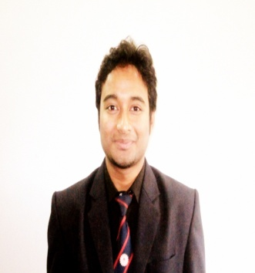

**ADDRESS**

L1/8, Vidyasagar Upanibesh,

PO – Naktala, PS – Patuli

Kolkata - 700047

Contact No: - 09830656657

Email Id: alimiaraj@gmail.com

**CAREER OBJECTIVE:-**

**To seek challenging assignment and responsibility, with an opportunity for growth and career advancement as successful achievements.**

**EDUCATIONAL QUALIFICATION**

|  |  |  |  |  |
| --- | --- | --- | --- | --- |
| **Qualified** | **Year of passing** | **SCHOOL/COLLEGE NAME** | **University / Board** | **Specialization** |
| P.G.D.M | 2014 | Bharatiya Vidya Bhavan(BCCM) | A.I.C.T.E | Marketing and Finance |
| B.B.A (H) | 2012 | Bengal Institute of Science & technology (BIST) | Burdwan University | Marketing |
| Higher Secondary (10+2) | 2009 | M.M High School,Purulia | W.B.C.H.S.E | Commerce |
| Madhyamik (10) | 2007 | C.R.H.S | W.B.B.S.E | General |

**PROJECT DETAILS**

**Summer Internship Project:**

* Project title is impact of sales promotion activities on consumers – a study on retail stores of Bhubaneswar with special reference to pantaloons.
* Project objective was to find out the strategies adopted by the retail stores to attract customers and the impact of these strategies on customers in terms of boosting sales**.**

**WORK EXPERIENCE**

|  |  |  |  |
| --- | --- | --- | --- |
| **Company** | **Job Designation** | **Job Profile** | **Time Span** |
| **India MART Intermesh Limited** | **Executive – Client Acquisition** | Approaching to new and existing clients, showing demo over i-pad and make contracts with clients. | **02-06-2014 – 02-11-2014** |

**COMPUTER PROFICIENCY**

* MS Excel, MS Word, MS PowerPoint

**LANGUAGE KNOWN**

* English
* Hindi
* Bengali

**SPECIALIZATION**

* **Marketing**
* Finance

**ACHIEVEMENTS**

* Certified as **“The Best Management Trainee”** at Pantaloons during development training.
* Stood in third position in chess competition at Bharatiya Vidya Bhavan (BCCM).

**PERSONAL DETAILS**

* Date of Birth: 01/04/1991
* Father’s Name: Syed Julhar Ali
* Sex-Male
* Category: General.

**HOBBY**

* Interacting with people
* Dancing (Break dancing and Free style dancing)
* Playing Chess and Football.

Hereby declare that all the above information which I have mentioned is true as per my knowledge and concern.

__________

Date Signature